**Class - I**

Q-1 Join the alphabets given below and from a word:-

(a)

(b)

(c)

(d)

Q-2 Read the given sentences write **a** and **an** accordingly.

(a) This is ……… apple.

(b) This is …….. book.

Q-3 What is your name?

Ans…………………………………………………………………………………… .

Q-4 How old are your?

Ans……………………………………………………………………………………………… .

प्र :5 अक्षरों को जोड़ कर शब्द बनाए।

प्र :6 अक्षरों को जोड़ कर शब्द बनाए।

1. स+ब :-_________________________
2. म +ट+र :-____________________
3. ब +ट +न :- ____________________
4. अ+द+र +क:-______________________

प्र :7 चित्रों के आधार के अनुसार मात्राएँ लगाएं ।

1. - पन b) न...व

Q-8 Count and write the number names of the given numbers.

(a)

(b)

Q-9 Write number just before the given numbers.

1. 42 (b) 60

Q-10 Write number just after the given numbers.

1. 62 (b)77

Q-11 Write numbers in between the given numbers:-

1. 46 48 (b)89 91

Q -13 Write the correct time in the given blanks.

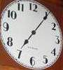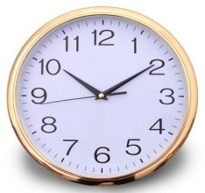

(a) (b)

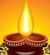 Q-14 Name the festivals celebrated given in the picture below:

1. 

Q-15 Draw the picture of a sun:-

Q-16 Name the means of transport given in the picture below:-

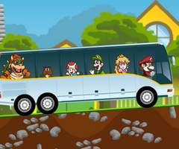

(a)

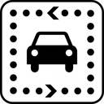

(b)